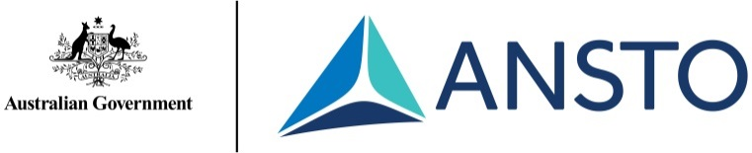

Year 7-10 Science
Tour outline and syllabus outcomes

ANSTO is a leader in chemical, materials and environmental research, and produces many of Australia’s medical radiopharmaceuticals.
ANSTO conducts Years 7-10 Science tours, which cover specific syllabus content in the NSW science syllabus. These tours consist of:
• A 45 minute circuit of hands on activities in our Discovery Centre theatrette
• A 15 minute break for students
• A 90 minute tour of ANSTO’s research facilities, including the OPAL research reactor, the Australian Centre for Neutron Scattering, and the Centre for Accelerator Science.
Syllabus content covered in tour | Tour content
Stage 5  CW1 a) identify that all matter is made of atoms which are composed of protons, neutrons and electrons  b) describe the structure of atoms in terms of the nucleus, protons, neutrons and electrons  d) Identify that natural radioactivity arises from the decay of nuclei in atoms, releasing particles and energy  e) evaluate the benefits and problems associated with medical and industrial uses of nuclear energy  CW2 a) identify the atom as the smallest unit of an element and that it can be represented by a symbol  b) distinguish between the atoms of some common elements by comparing information about the numbers of protons, neutrons and electrons  c) describe the organisation of elements in the Periodic Table using their atomic number | The ratio of protons and neutrons in the nucleus of an atom determines whether an isotope is stable or radioactive. We use our interactive SmartBoard atom-builder program and our diagram of radionuclides to demonstrate how the number of neutrons differs amongst isotopes of the same element.  We demonstrate how cloud chambers and Geiger counters can be used to detect natural radiation around us. Using a scintillation counter to test several safe radioactive sources in our discovery centre, we discuss the difference between alpha, beta and gamma radiation.  ANSTO produces a range of radioisotopes for industry and medicine. We discuss the benefits of using radioisotopes in medicine and industry, and outline the precautions taken to minimise the negative effects of radiation from these materials. We also discuss how we and other organisations around Australia manage nuclear waste safely.
Stage 4  ES1 h) describe examples to show how people use understanding and skills from across the disciplines of science in occupations related to the exploration, mining or processing of minerals in Australia  ES4 c) demonstrate how scientific knowledge of the water cycle has influenced the development of household, industrial and agricultural water management practices  CW4 e) propose reasons why society should support scientific research, e.g. in the development of new pharmaceuticals and polymers  f) describe, using examples, how science knowledge can develop through collaboration and connecting ideas across the disciplines of science, e.g. making or obtaining new substances from Earth’s spheres  Stage 5  PW3 d) outline recent examples where scientific or technological developments have involved specialist teams from different branches of science, engineering and technology, e.g. low-emissions electricity generation and reduction in atmospheric pollution  ES3 c) evaluate scientific evidence of some current issues affecting society that are the result of human activity on global systems, e.g. the greenhouse effect, ozone layer depletion, effect of climate change on sea levels, long-term effects of waste management and loss of biodiversity LW2  f) evaluate some examples in ecosystems, of strategies used to balance conserving, protecting and maintaining the quality and sustainability of the environment with human activities and needs  CW4 e) describe examples to show where advances in sciences and/or emerging science and technologies significantly affect people’s lives, including generating new career opportunities in areas of chemical science such as biochemistry and industrial chemistry | We explain ANSTO research and the roles of different scientists while touring the site. Please talk to our education officers before your tour about the content needs of your group.  E.g.  - Mining rare earth metals  - Understanding groundwater resources around Australia  - Monitoring trace metals in ecosystems  - Developing new radiopharmaceuticals  We emphasise that collaboration between scientists with different areas of expertise is necessary to conduct quality research. In particular, we explain how many facilities at ANSTO are available for use by scientists from different universities within Australia and internationally.  We are happy to answer students’ questions about science career opportunities at ANSTO and in other scientific organisations.

