Airport Shuttle Services
There are many options for shuttle buses from the Airport (Tullamarine) to the Australian Synchrotron, some that run only during business hours and others that run 24/7. Please see the list below for some potential options.

South East Airport Shuttle - http://www.southeastairportshuttle.com.au/
Aiport Bus Dandenong - http://www.airportbusdandenong.com.au/home
Airport Bus Eastside - http://www.airportbus.com.au/
Skybus Super Shuttle - https://www.skybus.com.au/

Taxi Hire and Driving
Taxi Hire
Taxis are generally readily available for use to destinations all around Melbourne.
Our preferred taxi service is: Platinum Taxi Service (Jimmy) 0412 291 296
Please note: The Australian Synchrotron does not provide users with cabcharge vouchers for travel. If you are travelling from interstate or New Zealand, please retain all receipts and present them to your host organisation.
Arriving by road
The main roads leading to Melbourne's city centre are the Hume Highway from the north (Albury Wodonga, Yass and Sydney), Western Highway from the west (Adelaide), Princes Highway from the east (Gippsland), and Princes Highway from the south-west (Geelong).
Toll road from Airport and City (CityLink & EastLink)
CityLink is Melbourne’s toll road system that encompasses the Tullamarine Freeway, the Monash Freeway and the EastLink Freeway.
Tolls can be paid over the phone or online via www.citylink.com.au
You can also purchase a day pass by calling 13 26 29.
Parking
All parking onsite is free of charge.

Local Public Transport
To travel on a Melbourne metro bus, train or tram you will require a Myki card.

Please see the Public Transport Victoria website for more information about public transport in Melbourne: www.ptv.vic.gov.au

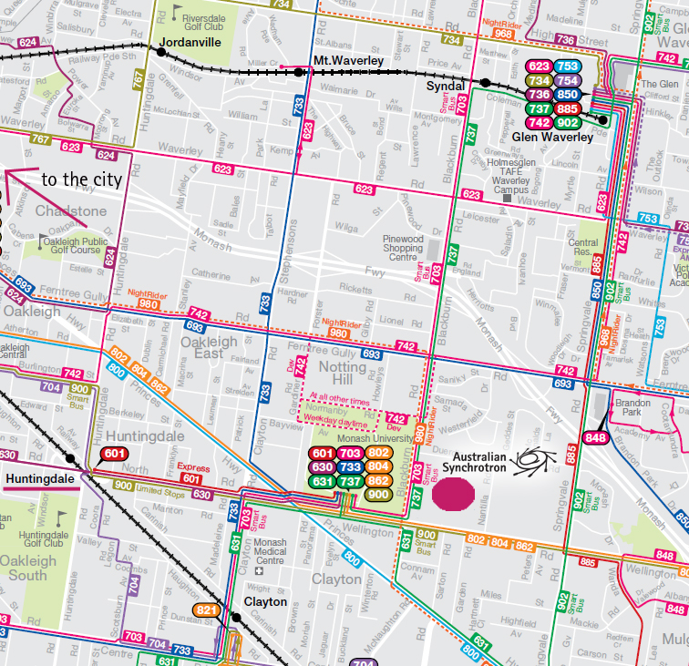

NightRider
For late night public transport between the City and Clayton, there is a NightRider Bus service that stops close to the Australian Synchrotron at Monash University. A timetable of this bus can be viewed or downloaded at: https://www.ptv.vic.gov.au/route/view/8970

Australian Synchrotron Pool Vehicles
The Australian Synchrotron has two pool vehicles on site which are available to User’s participating in beamtime.
Please contact the User Office if you would like to borrow a car.

